Communicable Disease / Pandemic Emergency Plan
Date: XXXXXXX

Table of Contents
SECTION 1: OVERVIEW 5
1.1 Introduction 5
1.2 Purpose and Scope 5
1.3 Plan Review/Maintenance/Distribution 5
1.4 Training and Exercises 7
1.5 Mutual Aid Agreements 7
1.6 Context for a Communicable Disease Emergency 8
1.7 Responsibilities 8
1.7.1 Local Level Responsibilities 8
1.7.2 Provincial Level Responsibilities 9
1.7.3 Federal Level Responsibilities 9
SECTION 2: CONCEPT OF OPERATIONS 10
2.1 Activation of the Communicable Disease Emergency /Pandemic Plan 10
2.2 Deactivation of the Communicable Disease Emergency /Pandemic Plan 10
2.3 Emergency Operations Centre Location 10
2.4 Key Components of Communicable Disease Emergency Planning 10
2.4.1 Communications 10
2.4.2 Surveillance 11
2.4.3 Public Health Measures 12
2.4.4 Infection, Prevention and Control Measures 14
2.4.5 Continuity of Health Operations 15
2.4.6 Laboratory Services 16
2.4.7 Antiviral Medication 17
2.4.8 Vaccines 17
2.4.9 Ethical Considerations 18
SECTION 3: RECOVERY AND EVALUATING THE COMMUNICABLE DISEASE EMERGENCY RESPONSE 19
3.1 Debriefing(s) 19
3.2 Recovery 19
SECTION 4: APPROVAL of PANDEMIC INFLUENZA PLAN 20
SECTION 5: APPENDICES 21
Appendix A 21
Volunteer Contact Information List 21
Appendix B 22
Handrub Procedures 22
Appendix C 23
Handwash Procedures 23
Appendix D 24
Contact Information of Internal/External Government Departments and Community Partners 24
Appendix E 25
Vaccination Priority Groups 25
Appendix F 26
Appendix G 28
Influenza Clinic Registration Sheet 28
Appendix H 30
Mass Clinic Equipment List 30
Appendix I 32
Sample pre-recorded messages for local telephone line 32
Appendix J 33
Pandemic Influenza Client Immunization Record 33
Appendix K 34
Supplies 34
Appendix L 35
Pandemic Tracking System 35
Appendix M 37
Points to consider when choosing an Alternate Care Site 37
Appendix N 38
Infection Control – for Clinic Staff 38
Appendix O 39
Physical Care of the Deceased 39
Appendix P 40
Example: Personal Protective Equipment Policy 40
Appendix Q 41
Potential Housekeeping Frequencies 41
Appendix R 43
Pandemic Planning Committee 43
Communication and Coordination 43
Surveillance 43
Health Care Services 43
Infection Control 43
Vaccines/Antivirals 43
Human Resources 43
Care of Deceased 43
SECTION 6: GLOSSARY 44

SECTION 1: OVERVIEW

Introduction
____________ First Nation acknowledges its role and responsibility in the event of a communicable disease emergency (CDE) such as pandemic influenza. ____________________ First Nation will work closely with key partners to implement an integrated, comprehensive, and coordinated plan in the event of a CDE.

Partners
Local | - ____________________ Community Health Center
Regional | - Identify local and Regional Hospitals
Provincial | - Identify Provincial Health Authority
Federal | - FNIHB, Health Canada

Purpose and Scope
The purpose of this plan is to minimize the impact of the CDE by helping the community
    - Prepare for, respond to, and recover from a CDE
    - Ensure a coordinated response to a CDE
    - Preserve the health and well-being of community members and staff
- Sustain essential operations.
The Plan includes:
    - Roles and responsibilities of ____________________ First Nation, and regional/ provincial /federal health partners;
    - The decision-making process to activate and deactivate the Plan;
    - A process for ethical decision-making during an emergency;
    - Key elements of communicable disease emergency preparedness and response.

Plan Review/Maintenance/Distribution
The following emergency management plans/agreements were reviewed to ensure consistency with the communicable disease emergency plan (add/ remove as relevant).

Local | - ____________________ First Nation All-hazards emergency plan  - ____________________ Community Health Center Business continuity plan  - ____________, Mutual Aid Agreement FD  - First nation Tribal Council
Provincial | - All-hazards emergency plan  - Public Health Act  - Provincial emergency management legislation
Federal | - Federal emergency management legislation
The Community Health Nurse is responsible for developing the community CDE plan. The plan will be reviewed annually by Pandemic Planning Committee. Changes to the plan will be made as required. The revised plan will be submitted to Health Center Director for administrative approval. After the plan is revised and approved it will be circulated/ recirculated amongst all staff and community partners.

Training and Exercises
Training and exercises are essential to emergency preparedness because they help individuals understand their role in the event of an emergency/disaster event. ____________________ First Nation supports employee training that includes but is not limited to the following:

- Basic Emergency Management
- Incident Command System
- Emergency Operations Centre
- Crisis Communications
- Stress management
- Promoting community resiliency

Exercises help communities prepare for emergencies. They provide an opportunity to develop relationships with community partners/stakeholders, assess operational readiness for an emergency, resource requirements and role clarity. ____________________ First Nation will hold communicable disease emergency preparedness exercises every 12 months.

The date of the next exercise is INSERT DATE.

Mutual Aid Agreements
Mutual aid agreements are written agreements with nearby communities to assist during an emergency. These agreements could include the type of support needed (for example, supplies, staff, or knowledge). It could also indicate how the community requests support, and who the request should come from.

____________________ First Nation has mutual aid agreements with the following communities. The agreements are attached to this Plan. Fire Chief updates the agreements every year.

Community Name | Last Update (Year) | Next Update Due (Year)

Context for a Communicable Disease Emergency
Communicable diseases spread from one person to another. They can also spread from an animal to a human. Small germs cause communicable diseases. Communicable diseases can spread in many ways. They may spread by:

    - Contact with:
      - Coughing, sneezing, and saliva (for example, flu, chicken pox, TB)
      - Body fluids like blood, semen, vomit, and diarrhea (for example, food poisoning, HIV)
    - Indirectly by:
      - Unwashed hands
      - Unclean surfaces
      - Unclean food or water
      - Bites from insects or animals

Some communicable diseases spread easily between people. This can become an emergency when many people get the disease.

A communicable disease emergency is a current and serious situation. It affects a community for a short time. The community may not have the resources to care for everyone. They may need help from other levels of government.

Responsibilities

Local Level Responsibilities

      - ____________________ First Nation is responsible to:
        - Develop, test and update the communicable disease emergency plan in collaboration with partners and stakeholders and as part of their community health planning process.
        - Support employee preparation for emergencies, including through training and exercises.
        - Coordinate with health officials at different levels of government, as well as municipal and community partners.
        - The Health Director or Community Health Nurse is responsible for the planning resources.
        - Review local and provincial outbreak management plans to ensure alignment.
        - Familiarize themselves with provincial emergency management and public health legislation.
        - Sharing CDE plans with community members.

Provincial Level Responsibilities

      - The Province of ____________________ is responsible for:
        - Communications to and from community
        - Access to provincial stockpiles (for example, vaccines, antivirals, and personal protective equipment)
        - Support to communities during an emergency (for example, staffing surge capacity, funding)

Federal Level Responsibilities

      - Public Health Agency of Canada (PHAC) is responsible to:
        - Integrate First Nations and Inuit communities’ considerations and realities into federal documents.
        - Communication
        - Coordination
        - Federal vaccine, antiviral, and personal protective equipment stockpiles

      - Indigenous Services Canada (ISC) is responsible to:
        - Access to health services
        - Prevention, preparation, and response to health emergencies

SECTION 2: CONCEPT OF OPERATIONS

Activation of the Communicable Disease Emergency /Pandemic Plan
The Health Director in conjunction with the Community Health Nurse may activate appropriate components of the communicable disease emergency plan based on situational requirements. When the plan or any of its components are activated, the Health Director or alternate will assume the lead role in notifying the Chief and Council, the executive Director, the community health nurse (who in turn will notify Provincial MHO), and the Regional FNIHB of the change in the situation and the implications related to same.

Deactivation of the Communicable Disease Emergency /Pandemic Plan
The Health Director in conjunction with the Community Health Nurse will deactivate the Communicable Disease Emergency Plan/or components of it or have key people meet on an ad- hoc basis when:
    - The public health emergency is declared over by Provincial MHO, and/or
    - Local impact has diminished to a level where normal services may be resumed.

Emergency Operations Centre Location
The emergency operations centre will be located at the Health Center. The back up location will be at the Band Hall.

Key Components of Communicable Disease Emergency Planning
The following provides an overview of the major components of CDE preparedness and response.

Communications
Communication of information and advice is often the first public health intervention during an emergency. Providing clear and consistent information about the disease, who it affects, how it spreads and ways to reduce risk is an effective way to help reduce the spread of infection before other interventions like vaccines are available. Communications should follow the principles of honesty, openness, and cultural sensitivity to build and maintain public trust. Communication should be accurate and consistent

____________________ First Nation will share communications via (check those that apply and add as necessary):
      - social media (Facebook, Community Web Page)
      - radio announcements
      - media interviews
      - press releases
      - mail-out notifications (ie. via email) Door to door flier delivery

Notices in Mailboxes at Post Office School Billboard
Fliers sent home from school, daycare Phone tree

____________________ First Nation will share communications in English and provide translation where possible.

The Health director in conjunction with the Community health nurse is responsible to communicate on health-related matters with community members, health facility staff, and other local/ provincial/ federal partners and stakeholders.

The Communication Lead of the pandemic planning committee or their delegate is responsible to communicate on non-health related matters related to the emergency with community members, health facility staff, and other local/ provincial/ federal partners and stakeholders.

The Executive director will receive all media inquiries during the communicable disease emergency and will ensure that those responsible for communication are designated speakers.

Key items to include in communications to the public are:
        - Local, provincial, national, and international situation
        - Level of risk
        - Public health response
        - Signs and symptoms
        - Recommendations including prevention measures, how to care for an ill family member, when to seek care, and when to stay home.

Surveillance
Surveillance between pandemics serves as a warning system. Surveillance during CDEs provides decision makers with the information they need for an effective response.

The purpose of surveillance during a communicable disease emergency is to provide data on the current status of the infectious disease (e.g., clinical cases, hospitalizations and deaths; severe clinical syndromes and associated risk groups; and demands on the health system); to detect the emergence of new cases in a timely fashion and to monitor the spread and impact on communities; and to rapidly prioritize and maximize an efficient response.

The Community Health Nurse or their delegate is responsible to report notifiable diseases to FNIHB. FNIHB public health epidemiologists will analyze the data.

Responsibilities will be assigned to the community Public Health Nurse who will report all surveillance data to the Communicable Disease Control Nurse. This Regional Nurse will then report all gathered surveillance information to FNIHB, Region Department and other stakeholders, as required. Surveillance information may be shared with the Community, as necessary.

Public Health Measures
Public health measures are non-pharmaceutical interventions to help prevent, control, or mitigate communicable diseases. These measures help reduce transmission of the disease to reduce the size of the outbreak, the number of severely ill cases and deaths, and reduce the burden on the health care system. Public health measures range from actions taken by individuals (e.g., hand hygiene, self-isolation) to actions taken in community settings and workplaces (e.g., increased cleaning of common surfaces, social distancing) to those that require extensive community preparation (e.g., pro-active school closures).

Provincial and federal public health authorities will provide advice on public health measures as the emergency develops. The provincial or federal MHO may enforce some public health measures as per their authority under the (Provincial Health Act and Regulations) (IS THERE A FEDERAL ACT???). Community Health Nurse is responsible to ensure that local public health measures align with advice given by local, provincial, and federal public health authorities. Direction and support will be provided on Public Health Measures, as required by ____________________ First Nation.

The following outline key Public Health Measures that ____________________ First Nation may implement during a Pandemic Influenza event or CDE.

a. Individual level public health measures may include (This is a partial list. Add/ revise/ remove as relevant for your community and the CDE. Consider helpful and harmful local/ traditional practices.):

Measure | Risk/ Impact | Mitigation Strategy | Trigger to recommend this  measure
Clean hands with soap and water/ hand sanitizer often | Accessibility of clean water and soap.  Accessibility of hand sanitizer, risks of human consumption of hand sanitizer | Community handwashing stations. | Ongoing promotion. Increased promotion during flu season and when there is known potential for CDE (ie pandemic declaration)
Respiratory etiquette | None | None | Ongoing promotion. Increased promotion during flu season and when there is  known potential for CDE (ie

 |  |  | pandemic declaration)
Don’t share personal  items | Households may not have enough for  each individual | Consider surge supply during  emergencies.
Mandatory screening/ treatment | Limits on personal freedoms; relationship strain between community and health services | Build relationship with community before emergencies; clear communication.
Recommend / Do not recommend  - Pipe Ceremony  - Hand Shaking  - Cancelling public events  - Sharing drug paraphernalia  - etc. | Local and traditional practices can provide significant benefits to mental and social health.
Self-isolate in home | Overcrowded housing; isolation | Facilitate access to necessities such as  groceries.
Vaccines/ pre-exposure  prophylaxis with anti- virials | Possible limited  supply; cost-benefit analysis

a) Community level public health measures may include:

Measure | Risk/ Impact | Mitigation Strategy | Trigger to start  implementing this measure
Close schools, daycares, community centres, | Loss of community and social support, possibly access to food or safe spaces | Additional community kitchen; phone support to  families
Cancel or modify  community | Loss of community  and social support,

programming,  sporting events Recreational activities | possibly access to food or safe spaces
Implement increased cleaning of public spaces | Cost and human resources | Possibly do some of your own cleaning  and sanitizing
Public awareness campaigns | May not address relevant issues, may not be culturally safe and responsive | Local input into campaigns; engage trusted community members and  experts
Isolation/ Quarantine/ travel restrictions | Limits on personal freedoms; social isolation; relationship strain between community and health services | Facilitate access to necessities, including social contact. | Normally recommended by local/ provincial/ federal health authorities under strict conditions
Alternative working strategies (ie. flexible hours or work  locations) | Access to internet for telework | Possible a work from ho me/ alternate work  hours policy

Infection, Prevention and Control Measures
Infection Prevention and Control (IPC) is key to preventing the spread of communicable diseases. Personal Protective Equipment (PPE) and IPC training are essential. IPC and Occupational Health and Safety (OHS) programs should work together to prevent staff, patient, and visitor exposure to communicable diseases during the provision of health care. See Appendix B and C for World Health Organization hand washing/rubbing steps.

The following elements of IPC and OHS programs are present in local health facilities to prepare and respond to communicable disease emergencies.

X | IPC and OHS professionals are provided by STC to the health care organization to  conduct education and training for front line staff.
X | Comprehensive IPC and OHS education and training on communicable diseases is provided yearly to health facility staff, first responders, security, schools, daycare, HeadStart personnel and Elders. A plan is in place to provide training if and when an  emergency occurs.

X | An organizational risk assessment has identified administrative controls and personal  protective equipment (PPE) to protect patients, health care workers and visitors in health facilities.
Organizational policies and procedures for IPC and OHS exist, including: (HEALTH)
- Point-of-care risk assessments
- PPE and fit-testing (underway)
- Housekeeping
- Surveillance for health facility associated infections
- Staff and patient vaccination policies
- Source control
- Facility outbreak management protocols that align with provincial outbreak management plans
- PPE supplies (currently working)
- Access to provincial and federal stockpiles (PPE, vaccines, and antivirals)
 | Working towards band wide OHS
 | Housekeeping, PPE needs to take place outside of health
Possible training for waste management control personnel and Housekeeping and
Maintenance

Continuity of Health Operations
A communicable disease emergency usually exceeds the capacity of the health system, particularly in remote and isolated communities. Communities will face an increased demand for health services. There may be a shortage of health professionals due to personal or family sickness. Family, friends, and volunteers may need to provide care to sick family members. Non- urgent health services may need to be postponed.

The Health Center Director is responsible to inform CHIEF/ COUNCIL/ Executive Director/Pandemic Planning COMMITTEE if the health facility’s capacity is exceeded and non- urgent health services are postponed. If health and public health services are available outside of the community, Pandemic Planning Committee Communications Lead is responsible to inform community members when, where, and what services may be accessed.

In a communicable disease emergency, the following strategies may be used to increase the capacity of the health facility:

- Additional staff (through STC; Consider: professional licensing, job descriptions, delegation authority, recruitment, agreements with neighbouring communities, agencies, or provincial/ federal government, funding)
- Additional supplies (Rubicon Distribution Center – FNIHB; Consider: funding, sourcing, contracts); consider MOU with Parkland
- Additional space (school; band hall; headstart/daycare; Consider: locally, agreements with neighbouring communities, medevacs)
- Self-assessment for health care providers planning to return to the workplace after illness (will consider putting this into place)
- Prioritization of health services listed in Health Center Business Continuity Plan

In the event of a communicable disease emergency, health services will be prioritized as Health Center’s Business Continuity Plan.

In the event of a communicable disease emergency, community services such will be prioritized as follows:

- Fire Services – ____________________ Volunteer Fire Department
- O&M services
- Finance
- Social Services/Social Development/Elder Support
- Store

Supplemental mental health and social support for community members and health staff may be required during and after a communicable disease emergency. The following partners and organizations may be contacted for culturally safe mental health and social support during a communicable disease emergency:

- STC CISM and Mental Health
- Mobile Crisis
- ____________________ Crisis Response (CISM) Team
- FNIHB

Laboratory Services
Laboratory-based surveillance is an important part of monitoring communicable disease activity.

Rapid identification of a communicable disease and timely tracking of disease activity throughout the duration of the emergency are critical to a successful response. In the early stages of a pandemic, laboratory services may also provide guidance on appropriate clinical treatment.

The purpose of laboratory services during a pandemic is to:

- Support public health surveillance by confirming and reporting positive results;
- Facilitate clinical management by distinguishing patients infected with the communicable disease from those with other diseases;
- Monitor circulating viruses for antiviral resistance and characteristics; and
- Assess vaccine match and support vaccine effectiveness studies.

Clinical Programs manager with STC is responsible to communicate with any relevant laboratories and ensure all relevant health care providers are aware of any new laboratory guidelines and protocols.
Positive test results will be reported as per local and provincial public health requirements. Please consider reporting to FNIHB regional office as well.

Antiviral Medication
Antiviral medication can be used to treat viruses (such as influenza) or to prevent viruses in exposed persons (prophylaxis). Antiviral medications are the only specific anti-influenza intervention available that can be used from the start of the pandemic, when vaccine is not yet available.

The Clinical Program manager STC is responsible to collaborate with provincial/ federal authorities to ensure an adequate supply of antiviral medication for the community. Provincial clinical guidelines for administration and reporting will be followed including side effects, adverse events, and unused medication. Please consider reporting this information to FNIHB Regional Office as well.

The Homecare Nurse maintains a list of the community’s most medically vulnerable residents. This list is located at the ____________________ Wellness Center. Individuals who are unable to visit the health facility will receive home visits for vaccination. These home visits will be conducted as per the local health facility guidelines.

The Community Health Nurse will communicate with residents regarding antiviral medication prioritization and availability.

Vaccines
Immunization, especially of susceptible individuals is the most effective way to prevent disease and death from influenza. High seasonal influenza vaccine coverage rates are a good predictor of pandemic vaccine coverage rates. Vaccination during influenza pandemics can build upon a strong seasonal influenza immunization program. The overall impact of the pandemic vaccine will depend on vaccine efficacy and uptake, as well as the timing of vaccine availability in relation to pandemic activity.

This component aims to provide a safe and effective vaccine to residents of ____________________ First Nation as soon as possible; to allocate, distribute and administer vaccines as efficiently and fairly as possible; and to monitor the safety and effectiveness of pandemic vaccine.

STC is responsible to collaborate with provincial authorities to ensure an adequate supply of pandemic influenza vaccine for the community. All community health nurses will obtain and maintain their immunization competency. Provincial vaccination procedures will be followed including reporting administration, side effects, adverse events, and unused vaccine. Please consider reporting this information to FNIHB Regional Office as well.

Site-specific vaccine storage protocols exist and will be followed. In the event that the vaccine provided exceeds the storage capacity of the health centre’s vaccine fridge, one of the additional fridges at the health center can be utilized to store vaccines

The Homecare nurse maintains a list of the community’s most medically vulnerable residents.
This list is located health center. Individuals who are unable to visit vaccination clinics will

receive home visits for vaccination. These home visits will be conducted as per the local health facility guidelines.

The Community health nurse will communicate with residents regarding vaccine priority requirements, clinic locations and times.

The Community Health Nurse is responsible for the logistics of setting up a vaccination clinic, including location, volunteers, and scheduling.

Potential clinic locations are: Band Hall, School, Elders Lodge, Daycare/HeadStart. Potential volunteers are listed in Appendix A.

Ethical Considerations
Communicable disease emergencies often present ethical dilemmas. Decisions may be required on when to provide or withhold vaccines, antivirals, and/ or treatment, among other things.

In the event that ethical dilemmas requiring a decision arise, relevant members of the Pandemic Planning Committee communicable disease emergency team have an agreement to work within the established Health Center Ethics Framework.

SECTION 3: RECOVERY AND EVALUATING THE COMMUNICABLE DISEASE EMERGENCY RESPONSE

Debriefing(s)
Processes, activities, and decisions made during the CDE response should be documented for future reference. The response should be evaluated to see what went well, what could be done differently, and what the outcome was. This evaluation helps ensure that lessons learned from the real-life event are captured and remain available to inform CDE plan revisions.

Debriefings are recommended following an emergency/disaster event, particularly after an evacuation has been ordered. All the following types of debriefs are recommended:
    - Quick tactical debriefing with CDE RESPONSE TEAM/ OUTBREAK TEAM (what went well,
what didn’t, how to improve);
    - Operational debriefing, including community partners/stakeholders (Appendix D);
    - Questionnaire (to volunteers, community partners/stakeholders, owners of building sites used, etc.) in order to identify gaps and future considerations for improvement; Development of an After-Action Report, a financial report, and a report to Executive Director, Chief and Council, Health Director, Director of Finance, STC, Pandemic Planning Committee members. Results of the report should also be shared with community members.

The Health Director or their delegate is responsible to organize the debriefings. Pandemic Planning Committee members or their delegate is responsible to ensure the lessons identified are incorporated into the communicable disease emergency plan.

Recovery
After the emergency is over, ____________________ First Nation will recognize the losses, celebrate the
community’s resilience and begin the healing process. The following events will be considered
after the emergency has been declared over.

- Community Gathering/Feast/Meal
- Community Meetings

SECTION 4: APPROVAL of PANDEMIC INFLUENZA PLAN

Approved by:  _____________Health Director | Date:
Approved by:  ______________ Executive Director | Date:
Approved by:  _______________ Chief | Date:

SECTION 5: APPENDICES

Appendix A

Volunteer Contact Information List

Name | Phone number | Email

Appendix B

Handrub Procedures

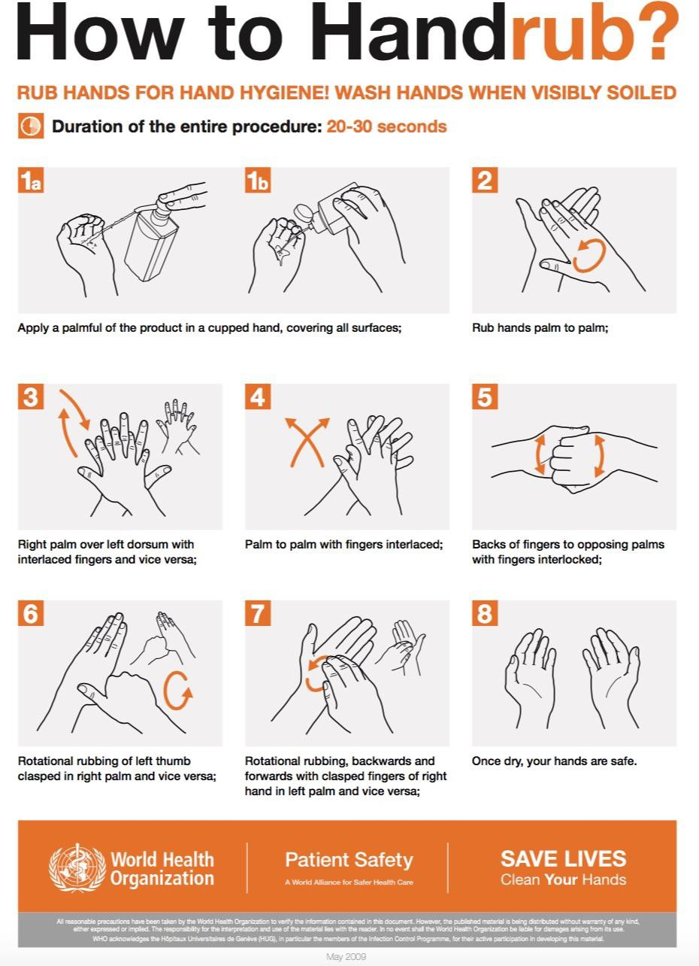

Appendix C

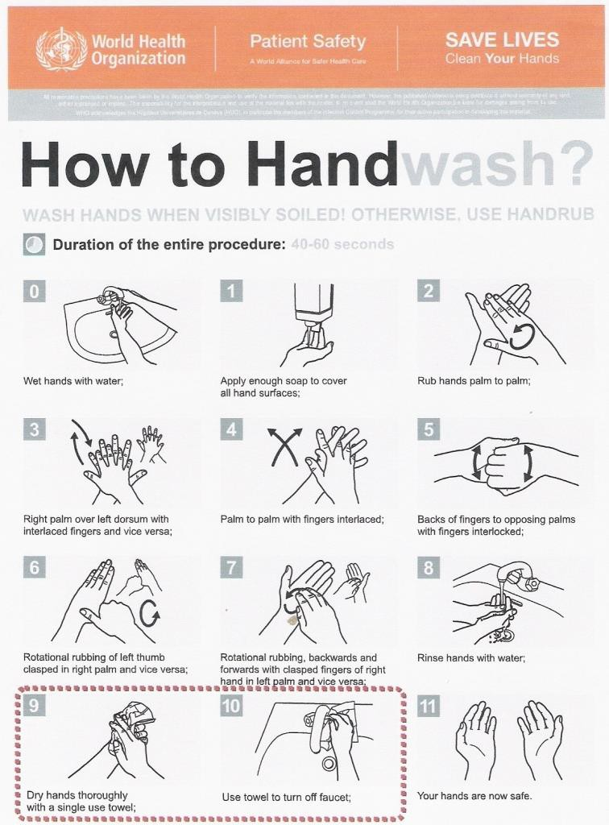
Handwash Procedures

Appendix D

Contact Information of Internal/External Government Departments and Community Partners

Title of person | Name | Phone number | Email

Appendix E

Vaccination Priority Groups

Priority groups are subject to change depending on how the illness spreads and which group of people is affected at the time. The scientific evidence at the time will dictate the recommendations made. Currently no vaccination priority groups are defined.

Health Canada’s recommended priority groups previously were as follows:

- Health care workers, paramedics/ambulance attendants and public health workers:
  - The health care and public health sector will be the first line of defense in a pandemic. Maintaining the health service response and vaccine program is central to the implementation of the response plan, in order to reduce the numbers of individuals affected.

- Essential Service Providers:
  - The ability to mount an effective pandemic response may be highly dependent on persons who are responsible for maintaining key community services. Those individuals included in this category should be defined based on the work/duties the individual performs rather than their job or position title.

- Persons at High Risk of Severe or Fatal Outcomes:
  - To meet the goal of reducing illness and death, persons most likely to experience severe outcomes should be vaccinated. For planning purposes this priority group has been based on the high-risk groups identified by the National Advisory Committee on Immunization (NACI) for annual vaccine recommendations.

Appendix F
Planning for Mass Immunization on Reserve Mass Influenza Immunization Clinic Operations

This planning guide is designed for clinics of 80 people or more. Location size can vary depending on the population to be served. It is recommended that people maintain a 3 foot or 1 metre distance during pandemic influenza.

- Clinic Layout and Flow:
  - Ideal location would be a place where person to person exposure is limited or can be controlled.
  - Clinics should have clearly marked entrance and exit points with adequate waiting space.
  - Traffic flow within the clinic should be controlled and follow a logical path from entry into the clinic to exit.
  - Easy to read signage should be provided to guide people through the clinic process.
  - If possible, registration and waiting room should be in a separate room from the vaccine administration and recovery area.

- Reception:
  - Clients arrive and are greeted by a volunteer. They are then directed to a designated area for a group presentation. If available offer written information.
  - People who do not have contraindications are asked to proceed to the appropriate alphabetical registration desk according to their last name.
  - Individuals who feel they have contraindications are asked to stay behind for further individual assessment by the Nurse. If the Nurse assesses that these individuals can be immunized, they are directed to the registration desk.
  - The number of registration desks will vary depending on the size of the community.
  - The following is a suggestion for a series of 6 registration desks with signage. Utilize a system that works best for your situation.

A, B, C, D | E, F, G, H | I, J, K, L, M | N, O, P, Q, R, S | T, U, V, W, X, Y, Z

- Registration:
  - Registration desks can be staffed by volunteers/clerical/or other non professional staff
  - The registration desk has one registration sheet for each letter of the alphabet
  - Client information is entered onto the registration sheet and then the client is directed to one of the immunization stations to receive the vaccine.

  - Following immunization, clients are given a record of immunization and are advised that they must present this record when they present for their second dose. They are then asked to move into the recovery area and wait for 15 minutes.

- Post immunization holding area:
  - Instruct client who reacts within 15 minutes to return to the nurse.
  - Preferably mats and water should be available in case someone feels faint.
  - Advise clients to return for the second dose of the vaccine. See Appendix G.

- Team Members Duties: rewriting to include pandemic planning committee members/roles

  - Team Leader (NIC or CHN)
    - Primary contact with the MHO and Regional office
    - Directs the activities of the community health facility and if priority groups are recommended by MHO then ensures that community aware and clients informed.
    - Picks up and delivers the supplies to the immunization location
    - Reviews with volunteers their roles and responsibilities. Ensures that everything is ready.
    - Responds to issues as they arise. Directs team members accordingly
    - Collects all records and supplies at the end of the day and returns to the office

  - Community Health Nurse
    - Sets up immunization stations*
    - Draws up and administers vaccine
    - Reviews pre-screening criteria, vaccine risks, benefits, and contraindications
    - Oversees the recovery area*
    - Tasks i and iv could be performed by volunteers/first responders, etc
  - Community Health Representative or Registrar
- Register clients ensuring that all information on the registration sheet is complete and legible
- Prepares the client immunization records for the nurse
- Direct clients to waiting area
- Collects the immunization information at end of day
  - Volunteers/Recorder Organizer-spokesperson
- Ensures the room is set to facilitate smooth traffic flow
- Has people roll one sleeve up in preparation for immunization (usually the non-dominant arm)
- Keeps people calm
- Runs messages and errands for staff, assists with record keeping as instructed by nurse
- Assists with holding small children for immunization
- Assists with all non-nursing tasks to reduce CHN responsibilities

Appendix G

Influenza Clinic Registration Sheet

Date:

Location:

Vaccine Lot #:

# | NAME | DATE OF BIRTH  (MM/DD/YY) | TREATY # | DOSE # | PRIORITY GROUP

LEGEND:

Select Priority Group A, B, C Refer to Appendix A for definitions

Appendix H

Mass Clinic Equipment List

Clinic Capacity: 50-80 clients/day/8 hour shift

Equipment requirements will be primarily dependent upon the facility selected and the expected clinic capacity. A secure area should be identified for receiving and maintaining supplies and equipment.
Vaccination campaign – the following equipment is primarily required for a vaccination clinic.

Item | Quantity Required
Adrenalin kits (containing adrenalin, dosage chart, tuberculin syringe and Benadryl)
Alcohol based waterless hand wash gel
Alcohol wipes
Benadryl
Client immunization records
Cotton balls
Date stamps and pads
Directional signs
Freezer packs
Juice
Kleenex
Large garbage bags
Nitrile gloves
Needles, 25 gauge 1” and 1-1/2”

Paper cups
Paper towels
Pens and stapler
Phone book??
Registration sheets
Scissors
Scotch tape
Sharps containers
Soap
Syringes (3cc)
Vaccine (doses/day)
Vaccine cooler/refrigerator
Vaccine information sheets

Appendix I

Sample pre-recorded messages for local telephone line

Today’s Day and Date

You have reached the ____________________ Community Health Center information line

- For information on clinic locations, press “1”
  - Sample Message
    - Site A: Eligible group – i.e. Priority A, B or C
      - Location
      - Times

    - Site B - Eligible group – i.e. Dose #2 call back for priority group A, B or C
      - Location
      - Time
      - Remember to bring your immunization card with you.

- For information on priority groups, press “2”.
  - Sample Message – listing of who is in each priority group.

- If you are calling with general questions about influenza or to report an adverse reaction to the vaccine you received, please call the Provincial Information line at 811.

Appendix J

Pandemic Influenza Client Immunization Record

Photocopy and cut up for use. Must be presented in order to receive 2nd dose.
Dose # 1

Date
C
B
Priority Group A
Date of Birth:
Name:
Vaccine Name:

Client Immunization Record
Dose # 1

Date
C
B
Priority Group A
Date of Birth:
Name:
Vaccine Name:

Client Immunization Record

Dose # 1

Date
C
B
Priority Group A
Date of Birth:
Name:
Vaccine Name:

Client Immunization Record
Dose # 1

Date
C
B
Priority Group A
Date of Birth:
Name:
Vaccine Name:

Client Immunization Record

Appendix K

Supplies

As part of the preparedness strategy, the recommendation is that each community keep an extra 5% of stock on hand. This amount may vary depending on how long items take to usually be received and how quickly they are used up in the day-to-day running of the clinic.
It is advisable to develop a tracking system for these supplies. See Appendix I.
The following is a potential list of items to have as extra on hand.
- Cleaning supplies e.g. bleach.
- Toilet paper tissue and paper towels.
- Garbage bags.
- Soap for hand washing (liquid and waterless).
- Laundry soap.
- Stretcher paper.
- Gloves (disposable, slightly powdered or non-powdered, non-sterile, non-latex, large and medium).
- Gowns – disposable non-sterile, impermeable.
- Masks (surgical and N-95).
- Face shield.
- Tongue depressors.
- Thermometer covers.
- Needles/syringes.
- Alcohol swabs.
- Disinfecting surface wipes.

Appendix L

Pandemic Tracking System
Location of Stockpile:

Facility:

Operational Period:

Date Prepared:

Prepared by:

Date | Item & Unit Size | Number on Hand | Number Ordered | Supplier Name/Location | Note (i.e. Expiry Date)

*Issues Affecting Supply:

Interrupted transportation lines – Canadian supplies travel long distances by truck, train and aircraft. Supplies are often obtained from the United States and other Nations. Difficulties at border crossings may substantially affect supply lines. In addition, a loss of up to 30 percent of workers, drivers, and other transportation staff may affect supplies.

Appendix M

Points to consider when choosing an Alternate Care Site

- Must have sufficient volunteers from community
- Parking space – how close can you get to the building with a vehicle?
- Emergency Vehicle Access?
- Wheelchair Accessible
- Ventilation System (airflow, air conditioning). Can the windows be opened? Are there a few separate entrances?
- Electricity
- Emergency Generator Power
  - Adequate plug-ins
- Heating
- Sanitation
  - Toilets working or are there outhouses available?
  - What is going to happen to the medical waste, if any?
  - What is going to happen to the general garbage?
- Water Supply
  - Showers #
  - Sinks #
- Safety Issues
  - Fire Alarms/Sprinklers
  - Evacuation routes
- Telecommunications Capability
  - Phone
  - Fax
  - Computer
  - Desk/Chairs
- Maintenance Services
  - Who does the cleaning?
- Food Services
  - Can food be cooked there?
  - Can food be stored there?
- Laundry Facilities
  - Washer/Dryer #
  - Does the community have its own Laundromat? Could it be used?
- Environmental/Cleaning Services
  - Medication or vaccine – how it would be stored.
  - Safekeeping for valuables/purses.
  - If a death occurred, where would the body be kept?
  - Sleeping area.
  - Rest area/Lounge.
  - Day care area.

Appendix N

Infection Control – for Clinic Staff

Suggested policies to have in place for health care staff:

- When and how to wash hands.
- When and how to wear gloves.
- When to wear a surgical mask or an N95.
- When to wear personal protective equipment.
- How to deal with bio-hazardous spill.
- How to deal with respiratory (SARS, Avian) and enteric infections in a clinic setting.
- How to package and transport hazardous goods.
- Location or written procedures on infection control.
- Reviewed yearly.

Suggested policies to have in place for cleaners and janitors:

- When and how to wash hands.
- When and how to wear gloves.
- When to wear personal protective equipment.
- How to deal with biohazardous spill.
- When and how to clean the various area of the clinic.
  - Type of cleaning supplies to be used.
  - Cleaning a clinic room versus an office area.
  - Frequency of cleaning – daily/weekly/yearly.
  - Cleaning the bathroom areas.
  - Stainless steel cleaning.
  - Floor care – dry and wet mopping.
  - Vacuuming.

Appendix O

Physical Care of the Deceased

Removal of the body by Health Care Worker

Label the body with name and identification information.

Personal Protective Equipment to be used by the Health Care Worker:

- Select the Medical Health Officer recommended mask (either surgical or N95* see note)
- Disposable long-sleeved, cuffed gown, waterproof if outside of body is visibly soiled with potentially infectious body fluids. If no waterproof gown is available, a waterproof apron can be used.
- Non-sterile, disposable gloves, single pair, should cover cuffs of gown. If splashing of body fluids is expected or possible:

Balaclava-type disposable cap Face shield or goggles
The body should be fully sealed in a waterproof body bag prior to removal and transfer to the Funeral Home or mortuary. Label outside of bag with same information.

No leaking of body fluids should occur, and the outside of the bag should be kept clean.

After removing Personal Protective equipment, perform hand washing. If Health Care Workers clothes were worn and became contaminated – when they are removed, fold inside out and place in disposable bag – avoid inhaling when closing or opening bag. (Wash clothes in warm soapy water.) Perform hand washing again and remove mask.

Transfer to mortuary or Funeral Home should occur as soon as possible after death.

For further information see WHO temporary infection control guidelines for health-care facilities:
http://www.who.int/csr/disease/avian_influenza/guidelines/infectioncontrol1/en/index.html

Note: Person must be Mask fitted within the past 2 years to wear N95

Appendix P

Example: Personal Protective Equipment Policy

Policy: All staff members will use/wear/personal protective equipment (PPE) as deemed necessary for the work assignment.

Purpose: To ensure that staff members are safe and healthy when performing the duties of their work.

Procedure: Protective equipment will be provided by ____________________ First Nation for staff to perform their duties safely. Gloves, gowns, eye shields, masks will be worn by staff when there is a possibility of being exposed to blood and body fluids.

Appendix Q

Potential Housekeeping Frequencies

Beds | Clean beds | 1 x annually/as required
Ceilings | Vents cleaned | 1 x month
 | Light fixtures washed | 1 x annually
 | Ceiling washed | 1 x annually/as required
Doors | Doorknobs and kick plates washed | 1 x weekly/as required
 | Door spot washed | 1 x daily
 | Door washed | 1 x weekly/as required
Flooring | Dust mopped | 1 x daily
 | Edges cleaned | 1 x weekly/as required
 | Wet mopped | 1 x daily
 | Baseboards cleaned | 1 x daily
 | Carpets vacuumed | 1 x weekly/as required
 | Carpets steam cleaned | 1 x annually/2 x annually
 | Carpet mat spot removal | 1 x weekly/as required
Furniture and Vertical/Horizontal Surfaces | Upholstery/furniture steam cleaned | 1 x annually/as required
 | Upholstery/furniture spot cleaned | 1 x daily
 | Furniture cleaned/vacuumed | 1 x weekly/as required
 | Vertical surfaces spot cleaned | 1 x daily
 | Vertical surfaces cleaned | 1 x weekly/as required

 | Horizontal surfaces spot cleaned | 1 x daily
 | Horizontal surfaces cleaned | 1 x weekly/as required
Walls and Door Frames | Wall spot washed | 1 x daily
 | Walls washed | 1 x annually/as required
 | High-low dusting (ledges) | 1 x weekly
 | Door frame/jam washed | 1 x weekly
 | General Dusting | 1 x weekly
Washroom Cleaning | Restock supplies | As needed
 | Clean toilets | 1 x daily
 | Clean sinks/Plumbing | 1 x daily
 | Clean mirrors | 1 x daily
 | Spot clean walls | 1 x weekly/as required
Waste Collection | Removal from rooms | 1 x daily/as required
 | Replace liner | 1 x daily/as required
 | Wash cans | 1 x weekly
Windows | Spot washed | 1 x daily
 | Complete cleaning | 1 x weekly

Appendix R

Pandemic Planning Committee

Communication and Coordination
This committee is in charge of rapid decision making. In the event of a pandemic situation, a communication plan describes who the leadership is, who will speak for the community and the process of how individuals interact with each other.

Surveillance
This committee will be responsible for monitoring (at a community level) which illness are present in the community. This allows for planning and implementation of controlled measures that may lessen the spread of the illness.

Health Care Services
This committee will be in charge of knowing which types of services are delivered to the public via acute care facilities, long-term care facilities and health and community service organizations. This includes health care service types in your community.

Infection Control
This committee will focus on what can be done at the community level to prevent or decrease the spread of disease.

Vaccines/Antivirals
This committee is in charge of vaccine care, identifying recommended priority groups, vaccine administration, ensure the community aware when vaccines and/or antivirals will be available.

Human Resources
This committee will be in charge of planning for utilization of volunteers and develop their roles and responsibilities for anticipation of major disruption in availability of On-Reserve community services.

Care of Deceased
This committee is responsible for developing a plan to cope with the possibility of increased deaths. As there is a potential that during a pandemic, the usual method of caring for the deceased may not be possible.

SECTION 6: GLOSSARY
Activation - The implementation of procedures, activities, and emergency plans in response to an emergency event, Universal Emergency Code, or disaster.

All-Hazards - Describing an incident, natural or manmade, that warrants action to protect life, property, environment, public health or safety, and minimize disruptions of government, social, or economic activities.

Business Continuity - An ongoing process supported by the Centers manager/s and funded to ensure that the necessary steps are taken to identify the impact of potential losses, maintain viable recovery strategies, recovery plans, and continuity of services.

Business Continuity Plan - A collection of procedures and information which is developed compiled and maintained in readiness for use in the event of an emergency or disaster.

Communicable Disease Emergency - Communicable diseases spread from one person to another. They can also spread from an animal to a human. Small germs cause communicable disease.
Communicable diseases can spread many ways. They may spread by:

- Contact with:
  - Coughing, sneezing, and saliva (for example, flu, chicken pox, TB)
  - Body fluids like blood, semen, vomit, and diarrhea (for example, food poisoning, HIV)
- Indirectly by:
  - Unwashed hand
  - Unclean surface
  - Unclean food or water
  - Bites from insects or animals

Some communicable diseases spread easily between people. This can become an emergency when many people get the disease.

A communicable disease emergency is a current and serious situation. It affects a community for a short time. The community may not have the resources to care for everyone. They may need to ask for help from other levels of government.

Disaster - An event that results in serious harm to the safety, health or welfare of people or in widespread damage to property
Emergency - A present or imminent event outside the scope of normal operations that requires prompt co-ordination of resources to protect the safety, health and welfare of people and to limit damage to property and the environment.

Emergency Management - An ongoing process to prepare for, mitigate against, respond to and recover from an incident that threatens life, property, operations, or the environment.

Incident -A relatively common situation requiring a specific response. It is generally handled by standard operating procedures and the agency/region has sufficient resources to respond.

Incident Command System (ICS) - A standardized organizational system that guides emergency response operations within MFN. The ICS assists in the comprehensive coordination and
management of resources. The ICS is used within the Emergency Operations Centre (EOC).

Preparedness - Activities, programs, and systems developed and implemented prior to a disaster/emergency event that are used to support and enhance mitigation of, response to, and recovery from disasters/emergencies.

Recovery -Activities and programs designed to return conditions to a level that is acceptable to the entity.

Response - Activities designed to address the immediate and short-term effects of the disaster/emergency event.

Resilience - The capacity of a system, community or society potentially exposed to hazards to adapt, by resisting or changing in order to reach and maintain an acceptable level of functioning and structure. This is determined by the degree to which the social system is capable of organizing itself to increase this capacity for learning from past disasters for better future protection and to improve risk reduction measures.

Risk - The likelihood of an event occurring multiplied by the consequence of that event, were it to occur. Risk = Likelihood x Consequence.

Stakeholder - An individual/s, agency (RCMP, Central Health), local municipality, department (fire rescue, Fire Emergency Services-NL) who has an interest in or investment in a community and who is impacted by and cares about how it turns out.

